INTRODUCTION:
Shake table is an experimental set-up where buildings can be vibrated using real ground motion to test the resistance of structures and to demonstrate the sensitivity of structures of different heights to the frequency of the ground motion.
To understand the behavior of rigid blocks (or furniture) to given amplitude and frequency of ground motion. Shake table is an experimental set-up where buildings can be vibrated using real ground motion to test the resistance of structures and to demonstrate the sensitivity of structures of different heights to the frequency of the ground motion.
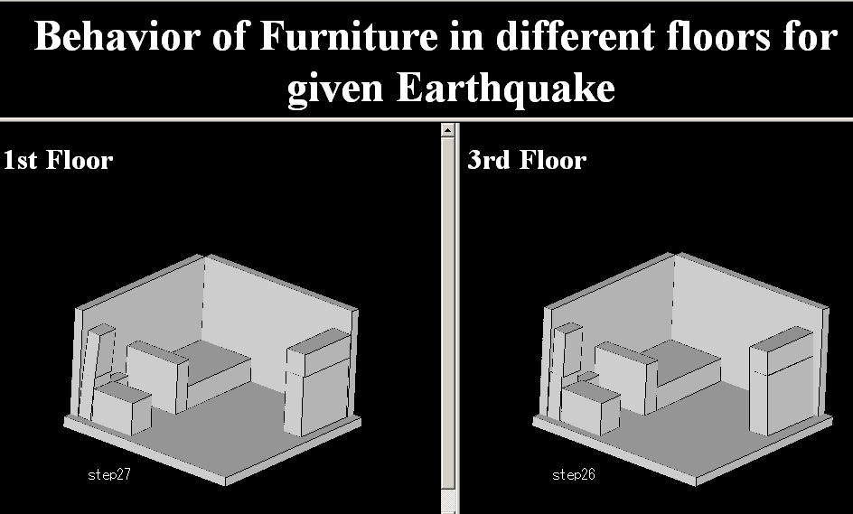

THEORY:

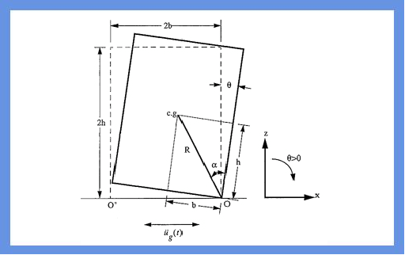
The equations that govern the rocking motion under the simultaneous presence of,
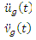
-- horizontal ground acceleration and,
-- vertical ground acceleration are
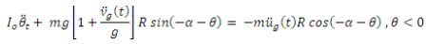
and,
For Rectangular blocks,
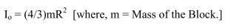
The above two equations are linearized to get the time history of angular displacement
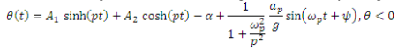
and,
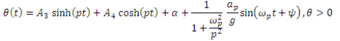
Where,
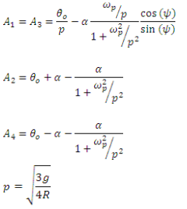
where,
g = Frequency.
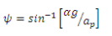

OBJECTIVE:

To understand the behavior of rigid blocks(or furniture) to given amplitude and frequency of ground motion.
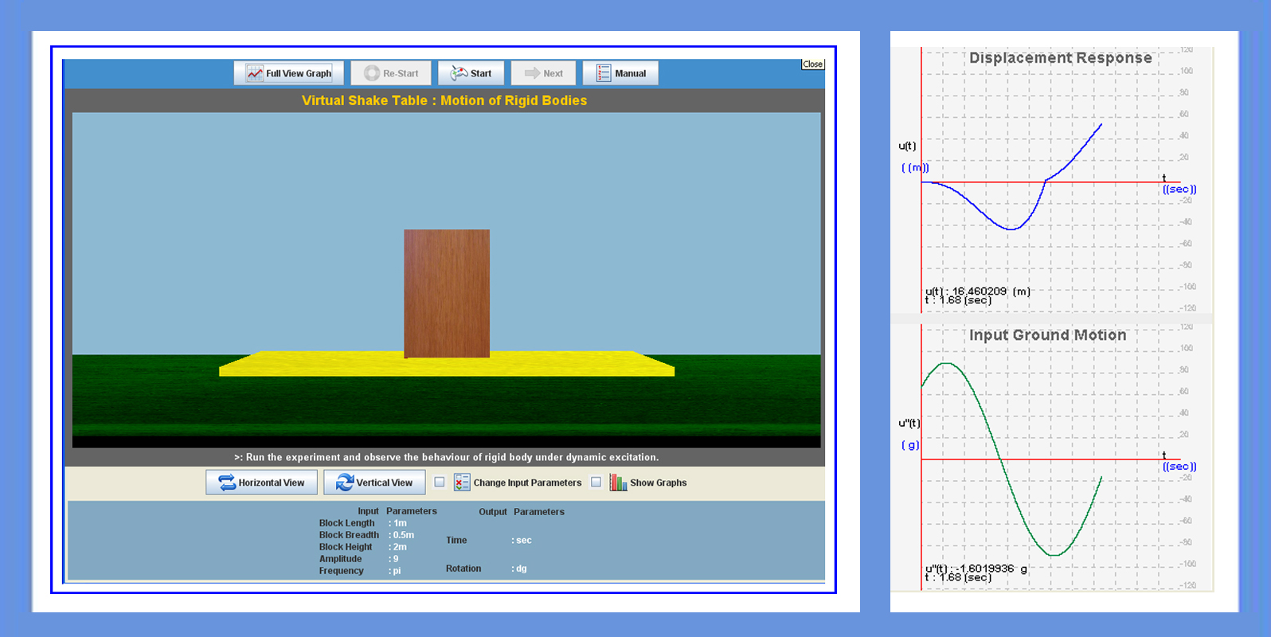

MANUAL:
Start the experiment with the default values of length, mass and intial displacement (in angle). Pause the experiment after few cycles and note the observation.

Observation 1: Rocking behavior of the rigid block to given displacement
1. Observe the rocking behavior of the block and also the energy loss during each impact.
2. User can note the zero crossings of the displacement and calculate the time period.
3. User can also compare where the time period remains same under different amplitude conditions.
Observation 2: Rocking behavior of the rigid block to given excitation
1. Screen shows the rigid block of default dimensions. User can change the dimensions of the block.
2. User can select the amplitude and natural frequency of input excitation.
3. Run the experiment and note the maximum amplitude corresponding to each excitation frequency and also amplitude.
4. Using the data obtained an envelope can be generated which gives the stable zone of the block under different excitation conditions.
5. Repeat the same with stiffness.
6. Change the structures stiffness (i.e., change column size) and observe the affect on time period.
7. Run the experiment for different values of stiffness and note the time period every time stiffness is changed.
8. Draw the graph between stiffness and time period.
9. Again start the experiment this time modifying the values of building parameters and initial conditions.
Observation 3:
1.Add damping to the system (i.e., 5%) and run the experiment.
2. Observe the effect of damping on time period and amplitude
3. Run the experiment for different values of damping and note the time period every time damping is changed.
4. Draw the graph between damping and time period.
Observation 4:
1. Add damping to system (i.e., 5%) and run the experiment.
2. Run the experiment and stop after few cycles.
3. Note the values of displacement on consecutive troughs and check the value of damping by logarithmic decrement formula.

PART - 2
ANIMATION STEPS
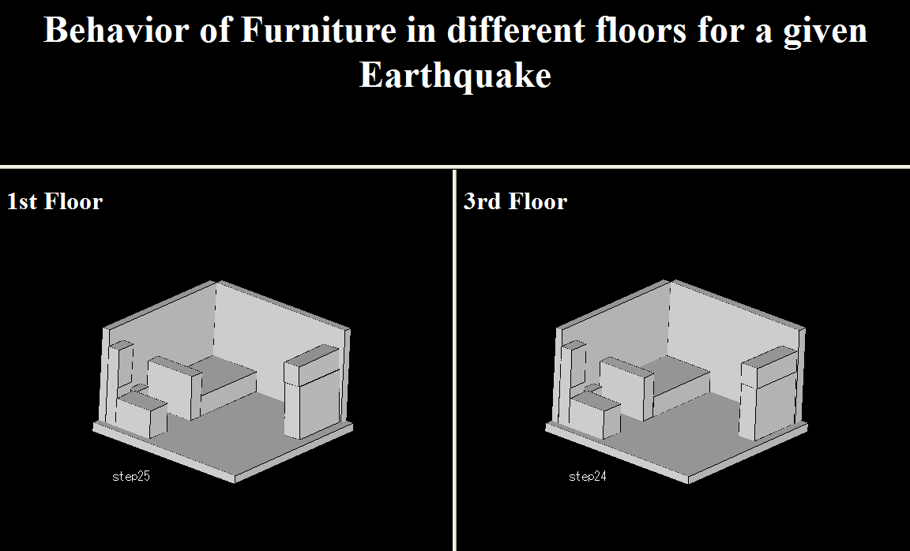

PART – 3
VIRTUAL LAB FRAME
